Drug and Alcohol Policy

September 2019

Introduction

The aim of this Drug and Alcohol Policy is to acknowledge and clarify the school’s role in drug prevention and education, and ensure it is appropriate to meet pupils’ needs. This policy provides information about drug education, as well as procedures to respond to any drug-related incident.

This policy aims to ensure that the approach taken on the issue of drugs is a whole-school one and is part of our commitment to, and concern for, the overall health and well-being of the whole school community. Teachers will need to be confident and skilled to teach drug education and pupils need to receive up to date, relevant and accurate information, as well as support.

This policy should be read in conjunction with the policies and documents listed on the back page of this document.

Statutory Duties

Schools have a statutory duty to promote pupils’ wellbeing and hence have a clear role in preventing drug misuse as part of their pastoral care. Although there is no statutory requirement to have a Drug Policy, it is the advice of the DfE, and a requirement for all Cognita schools to have a clear procedure for managing any incidents. It is essential to protect staff, parent/carer(s) and children and young people.

The Statutory Framework for the Early Years Foundation Stage (2014) requires the following (para 3.56): ‘Providers must not allow smoking in or on the premises when children are present or about to be present.’ While there is no specific requirement to hold a no-smoking policy per se, Cognita schools are required to continue to maintain as such. This includes offsite trips and visits. Furthermore, practitioners must not be under the influence of alcohol or other substances as per their Code of Conduct.

Application

This policy applies to all pupils on roll at the school. It applies when being educated in school, when on educational visits, and when off-site at school related events. This policy applies when pupils are travelling to and from school on public transport. Any responsibilities of ‘adults’ refers to employees and others acting in a supervisory role with pupils.

3.2 This policy applies to all pupils including those in the Early Years.

Terminology

‘Drugs’ here are taken to mean those that are legal, such as alcohol, tobacco and solvents, over the counter and prescribed drugs, and illegal drugs such as cannabis, ecstasy, amphetamines, heroin, crack/cocaine, LSD, etc. ‘Drugs’ also include New Psychoactive Substances (NPS) often referred to as ‘Legal Highs’.

The School’s Stance on Drugs, Health and the Needs of Pupils

Possession: It is inappropriate and unacceptable for pupils to bring the above drugs into school, have them on their person, consume them before, during and after school and on the way to or from school, including on school visits, etc. Cognita has a strict no smoking policy (including no vaping) on school sites. The drugs/substances covered by this policy are not to be purchased, sold or otherwise exchanged during the school day or while pupils are on school visits.

Use: The school believes that the use of drugs in school, during the school day, while travelling to/from school or on school trips is inappropriate. Individual exceptions may be made for pupils who require prescription medicines, where appropriate and with the agreement of the head teacher.

Policy Framework

Drugs Education
- The school provides drugs education in the following way:
Year 1 use the Christopher Winter project materials focusing on medicines and people
who help us
- The school uses the following external support and guidance to deliver its drugs education programme: Christopher Winter project

Staff Support and Training
The school is committed to providing drug awareness training in the induction of all staff working at the school and on an ongoing basis for staff involved in drugs education.

Management of an Incident
- Where there is evidence or suspicion that a pupil has drugs in their possession, has used drugs or has passed/sold on drugs to another person, the school will initially seek medical attention for the child if needed as per 7.3.
- The school will follow its Behaviour and Exclusion Policies and may also use its power to search a pupil. Sanctions will be applied as outlined in the Behaviour and Exclusion Policies.
- Where it is believed that a parent or carer is under the influence of drugs (including alcohol) on the school premises, they will be asked to leave. If they are due to collect their child, then they will be asked to make alternative arrangements and the child will be withheld to ensure their safety. If a parent or carer refuses to leave, the Headteacher or their representative should call the police. Where there are serious or ongoing concerns about the adult’s presentation and drug use, the school may consider banning a parent from entering the school site.
- See Appendix B – Responding to incidents involving drugs.

Police and Emergency Involvement
- The school will immediately refer illegal or unlawful incidents to the police.
- See Appendix A for guidance on drug situations linked to medical emergencies.

The Needs of Pupils
The school will exercise its pastoral responsibilities and always look to support pupils and ensure that pupils have access to appropriate support and guidance.

Information Sharing
If the school has concerns about a child’s safety, the school will share information with law enforcement agencies and safeguarding agencies as outlined in the Safeguarding Policy. This includes working in partnership with external agencies.

Involvement of Parent/Carer(s)
The school will inform parents and carers of any drug related incidents unless in very rare incidents this would heighten the risk to the child.

Staff Conduct and Drug Use
All staff are required to adhere to the Staff Code of Conduct. Staff are subject to the Cognita disciplinary and other HR procedures should they breach policy.

The Role of the Headteacher
- The Headteacher takes overall responsibility for the implementation of this policy.
- The Head will ensure that all staff dealing with substance issues are adequately trained and supported.
- Cognita cannot knowingly allow premises to be used for the production or supply of any controlled drug. Where it is suspected that substances are sold on the premises, details of those involved, together with as much information as possible, will be automatically passed to the police.

Implementation of this Policy

Schools are strongly advised to adopt the procedures set out in DfE and ACPO Drug Advice for Schools (DFE-00001-2012) when dealing with incidents involving substance misuse or supply on the premises/during the school day or during school trips and visits, etc.

The Headteacher should ensure that all staff, parents/carers and pupils are reminded of these procedures on an annual basis.

Situations requiring first aid will be dealt with immediately as per the school’s agreed policies and procedures. Information about emergency help for people who have had a bad reaction to drugs can be found at http://www.talktofrank.com/emergency-help.

In cases of substance misuse or supply on the premises during the school day or during school visits, medical attention will first be sought where needed as per 7.3. At an appropriate time, the case will be discussed with the young person and a written record taken (see Appendix C). Parents/carers will be informed by the Headteacher as soon as possible following an incident. The support of outside agencies will be sought if appropriate, including making referrals to children’s social care if risk is identified for the child misusing/dealing drugs.

While there is no legal obligation to inform the police, they may be involved at the discretion of the Headteacher in consultation with the Director of Education. The school will consider each incident individually and will employ a range of responses to deal with individual incidents. The Headteacher will inform the Director of Education in relation to all drug-related incidents.

If there is a significant seizure of a suspected illegal substance, schools should inform the police at an early stage and take steps to minimise handling the substance to aid future forensic investigation.

Specific Procedures

Dealing with Information and Confidentiality

- Schools are an important source of support for pupils experiencing problems with drugs and must ensure that all staff (teaching and non-teaching) understand the limits of confidentiality, balancing the desire to maintain confidentiality and support the young person with the duty to safeguard and promote the welfare of the young person and others. The school Safeguarding and Child Protection Policy and Procedures must be followed. Staff cannot and should not promise confidentiality to the pupil.
- There are important reasons why personal and sensitive information needs to be shared in relation to child protection (e.g. when working with the police, referral to external agencies, etc.). Data protection legislation, namely, the General Data Protection Regulation 2016 (as amended, extended or re-enacted from time to time) and Crime and Disorder Act allow personal information to be shared if there is an over-riding public interest in the first instance, or to prevent crime and disorder in the second. However, in assessing the suitability of sharing information, all efforts should be made to encourage the young person to give their informed consent. If a decision is taken to share confidential information, a written record of any concerns, including the reasons for breaching a pupil’s confidentiality, should be made.
- The following questions should also be considered:
- How serious is the situation?
- What immediate and significant risk does the young person face?
- What implications (both positive and negative) could keeping a confidence have?
- Could there be a transfer of risk to other children?
- Could significant harm result from keeping the young person’s disclosure confidential?
- If a confidence needs to be broken, the school should explain to the young person (and parents/carers as appropriate): why the confidence was broken, who will be/has been informed, what will be/was disclosed, how the information will be used and that their privacy will be respected.

Parental Substance Misuse
- Parental substance misuse has the potential to impact negatively on outcomes for children and young people. ‘Hidden Harm: Responding to the Needs of Children of Problem Drug Users’ ( ACMD: 2003) estimated that 2-3 per cent of children are affected by problematic parental substance use. This estimate only covers parents with serious dependencies on heroin and crack cocaine, and does not account for children affected by alcohol or other drug use in the household.
- Substance use in itself is not a reason for considering a child to be suffering or at risk of suffering significant harm, although it may be a contributing factor.
- The DSL or Head will liaise with the police and/or external agencies where required.

Legal Drugs
The police will not normally need to be involved in incidents involving legal drugs, but schools may wish to inform trading standards or police about the inappropriate sale or supply of tobacco, alcohol or volatile substances to pupils in the area.

Controlled Drugs (including New Psychoactive Substances)
In taking temporary possession of suspected controlled drugs, the school will:
- Ensure that a second adult witness is present throughout;
- Seal the substance in a plastic bag and include details of the date and time of the seizure/find and the witness present;
- Store it in a secure location, such as a safe or other lockable container with access limited to senior members of staff. DO NOT dispose of the substance since disposal can now only be done by the constabulary;
- Notify the police without delay, who will collect it and then store or dispose of it in line with locally agreed protocols. The law does not require a school to divulge to the police the name of the pupil(s) from whom the drugs were taken but the police advise that this is disclosed. The school should determine their position on this in advance to ensure consistency of approach;
- Record full details of the incident, including the police incident reference number if they are involved;
- Inform parents/carers,
- Identify any safeguarding concerns and respond appropriately; and
- If there is a significant seizure of a suspected illegal substance, schools should inform the police at an early stage and take steps to minimise handling to aid future forensic investigations.

Searching, Screening and Confiscations
DfE guidance states that: school staff can search a pupil for any item if the pupil agrees, noting that the ability to give consent may be influenced by the pupil’s age or other factors. Headteachers and staff authorised by them have a statutory power to search pupils or their possessions without consent where they have reasonable grounds for suspecting that the pupil may have a prohibited item. Prohibited items include alcohol and illegal drugs. The law says that the person conducting the search may not require the pupil to remove any clothing other than outer clothing.

Use of External Input
- Children and young people often find visitors to school a useful and informative part of their learning, but equally research suggests that for visits to be successful there should be a shared understanding about the nature and content of the session/s. Government guidance is that schools should exercise caution with the use of visitors as there is some evidence that particular messages can have a detrimental impact on young people’s intentions to resist using drugs including alcohol. Particular caution should be used when visitors have had first-hand experience of problematic drug use.
- Schools should ensure that visitors are appropriately qualified and trained to deliver work with children and young people in a school setting. They should also be aware of good practice that recommends the avoidance of shocking images and inappropriate descriptions of drug use, have a clear understanding of the aims and objectives of the session and have seen and understood this policy.
- Visitors must be briefed on any particular sensitivities that there may be in the pupil group – these may include identified drug issues by particular pupils or their families – as well as any broader needs within the group. Teachers should negotiate the content of the session which is linked to the broader drug education and PSHE delivered by the school and relevant to the identified needs of the pupils. Visitors should be made aware by the teacher of the school’s protocols for dealing with any disclosures or distress shown by pupils during the session.
- Teachers should be present at all times when such a visitor is in the class, and be ready to be an active participant in these sessions. They should ensure that they reflect on the learning from particular sessions with pupils and visitors, assessing the learning, and building skills to support and enable pupils to make healthy choices and to avoid risk-taking behaviour. Teachers should follow-up any unresolved issues or concerns and extend the learning begun by the visitor.

National Support and Advice from Organisations
- Drinkline: A free and confidential helpline for anyone who is concerned about their own or someone else’s drinking: 0800 917 8282.
- Family Lives: A charity offering support and information to anyone parenting a child or teenager. It runs a free-phone helpline and courses for parents: 0800 800 222.
- FRANK: National drugs awareness campaign to raise awareness among young people and their parents/carers: www.talktofrank.com. Schools can receive free resources, updates, newsletters etc.
- Smokefree: NHS stop smoking support: www.nhs.uk/smokefree.
- FRANK: Advice on what to do to help someone who’s having a bad reaction to drugs: www.talktofrank.com/emergency-help.
- Resuscitation Council (UK): Guidelines for resuscitation procedures: www.resus.org.uk/pages/GL2010.pdf.

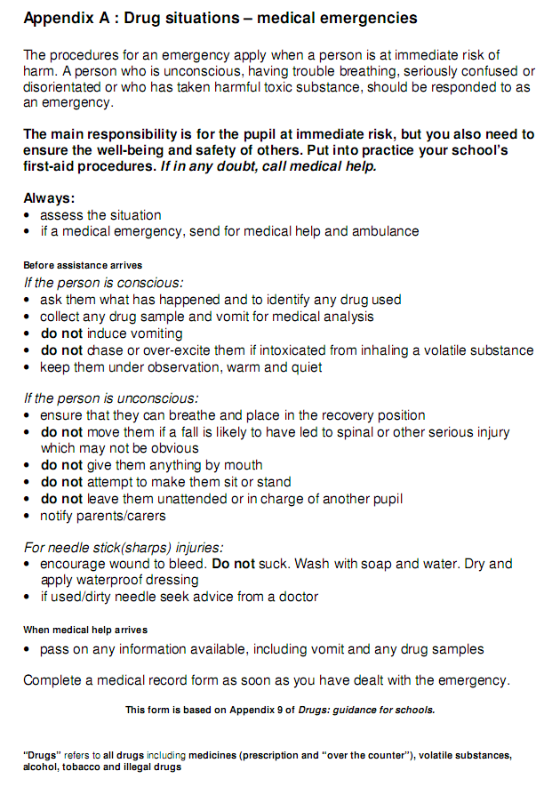

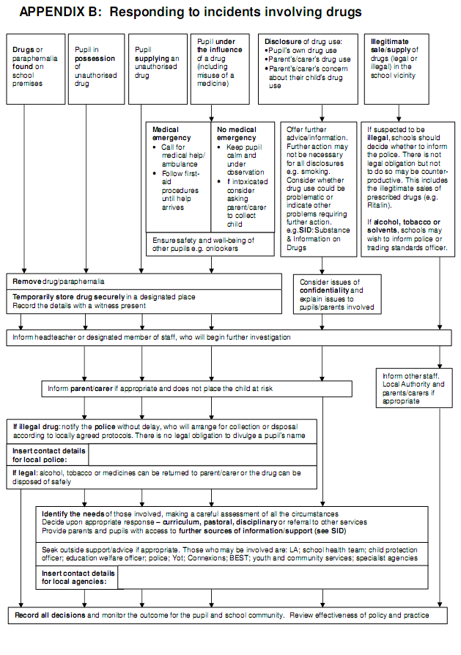

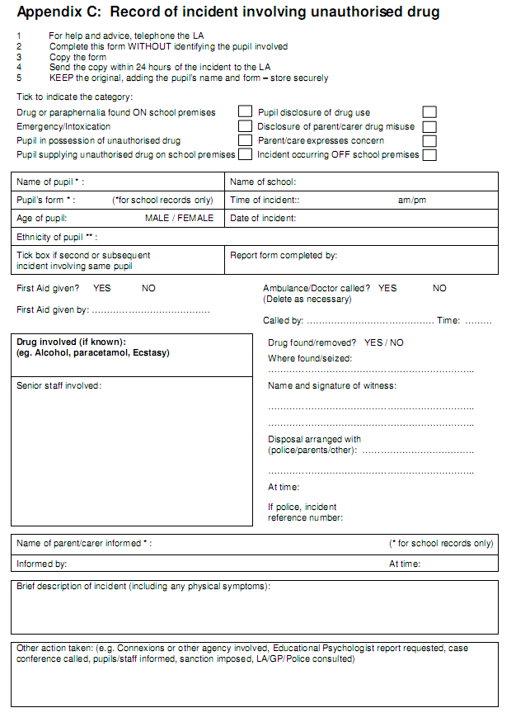

Ownership and consultation
Document sponsor (role) | Group Director of Education
Document author (name) | Karen Nicholson, ADE, reviewed by Alison Barnett 2018 and 2019
Consultation – May 2017 | Consultation with the following schools: Downsend Epsom Pre-Prep School, Breaside Prep School, Hendon Prep School, Salcombe Prep School, North Bridge House Canonbury School, Huddersfield Grammar School, Hastings School Madrid and El Limonar Villamartin.  Education Team representative: Danuta Tomasz, ADE.

Audience
Audience | All school staff

Document application and publication
England | Yes
Wales | Yes
Spain | Yes

Version control
Implementation date | September 2019
Review date | Review and update for implementation in September 2020

Related documentation
Related documentation | Safeguarding and Child Protection Policy  Behaviour Policy  Exclusion Policy  SEND Policy  Complaint Procedure  Educational Visits Policy  Health and Safety Policy  Curriculum Policy, including PSHEE  Staff Code of Conduct  Use of Reasonable Force  Guidelines on Searching Pupils

